5.9

Pause inventory trading.

Pause fast MA

Focus on big picture first.

* Stable MA as a determination of delta.
* No short during the day. (historically 8 bps rise per day)
* Delta direction is consistent with 20d dma.

Issue with current inventory trader

1. If suddenly goes in the opposite direction, the last trade is at the extreme
2. Not good in trendy markets
3. For trendy markets, simple MA trader works better. Inv trading would
4. Advantage is no need to take delta risk.

Devise a percentile trader that checks at each T for opportunity for accu and deccu

1. Eager dissemination. Don’t want to impact net delta.
2. Interval T (note when interval T goes to super small, it is same as inventory trader)
3. Trade at t based on percentile, at T+1, if profit, sell.
4. Accumulation is based on global percentile.
5. You can trade day percentile, AM, PM percentile.

Proposal 1:

1. Trade every 15 min (or any fixed T)
2. < 20 perc, buy. > 80 perc, sell. (new trades) (perc_open). Buy open and sell open
3. At every t, if previous trades are profitable, close them (perc_close)

Proposal 2:

1. Same as inventory trader, but change entrance from SMA to percentile.
2. Change $5 target -> wait t minutes.

Determination of net delta based on

1. 60 Day moving avg. (main strength)
2. 60 5-min bar moving avg. (local strength)
3. Percentile trader shouldn’t trade around the pos, not mess around with the net delta.

5/12 weekly review

Stocks were up 50k, fut down 50k.

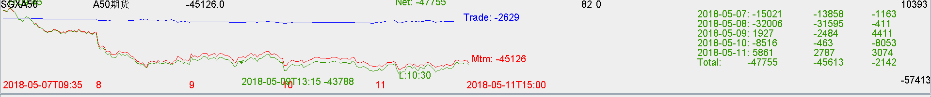

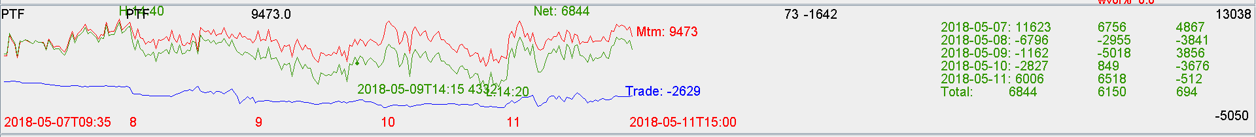

Traded 236 lots. Cost 350 USD just for transaction.

Trade pnl loss was -2k RMB.

Good

1. Attempting to implement auto trader
2. Inventory trading entrance was buying high and selling low, changed to high percentile sell first and low percentile buy first (so accumulation will be favorable)
3. Net delta is not handled well this week. There should be an anchor delta and net delta should not be allowed to drift too far from it.